NAME – AASTHA
ROLL NO. – 2025010003
IT PROJECT MANAGEMENT
PROJECT NAME – HABIT GUARD AI

TASK—
HabitGuard AI: An Intelligent Habit Accountability and Activity Verification System

FUCNTIONAL REQUIREMENTS –
IDs | REQUIREMENT | DESCRIPTION
 | User Registration | The system shall allow users to create an account using their basic details and password.
  FR-01
 | User Login | The system shall authenticate registered users and provide secure access to their account.
  FR-02
 | User Authorization | The system shall ensure that users can access only their own commitments, tasks, submissions, and progress.
  FR-03
 | Create Commitment | The system shall allow users to create a personal habit/commitment with its required details.
  FR-04
 | Manage Commitments | The system shall allow users to view, update, and manage their active commitments.
  FR-05
 | AI Daily Task Generation | The system shall generate a daily task related to the user's selected commitment.
  FR-06
 | Task Personalization | The system shall generate tasks appropriate to the user's commitment rather than assigning unrelated activities.
  FR-07
 | Task Variation | The system shall avoid repeatedly assigning the same daily task in order to reduce redundancy.
  FR-08
 | Daily Task Display | The system shall display the assigned task clearly to the user for the current day.
  FR-09
 | Proof Image Upload
  FR-10
  The system shall allow users to upload an image as evidence of completing the assigned task.
 | Image Validation | The system shall validate the uploaded image before processing it as proof.
  FR-11
 | AI Proof Verification | The system shall analyze the uploaded image and determine whether it is relevant to the assigned daily task.
  FR-12
 | Duplicate Proof Detection | The system shall detect whether the same or substantially similar image has been submitted previously by the user.
  FR-13
 | Invalid Proof Handling | The system shall reject proof that is irrelevant, invalid, or identified as a reused submission.
  FR-14
 | Completion Confirmation | The system shall mark the daily task as completed only when the submitted proof passes the required verification.
  FR-15
 | Streak Management | The system shall calculate and maintain the user's consecutive successful completion streak.
  FR-16
 | Missed Task Detection | The system shall identify tasks that were not successfully completed within the required period.
  FR-17
 | Accountability/Penalty Handling | The system shall apply the defined escalation or penalty mechanism when a commitment is missed.
  FR-18
 | Progress Tracking | The system shall store and track daily completion and missed-task records.
  FR-19
 | Dashboard | The system shall provide a dashboard displaying commitments, today's task, streak, completion status, and progress.
  FR-20
 | Submission History | The system shall allow users to view their previous task completion and proof-submission records.
  FR-21
 | Session Management | The system shall maintain authenticated user sessions and allow users to securely log out.
  FR-22

NON- FUCNTIONAL REQUIREMENTS –
IDs | REQUIREMENT | DESCRIPTION
 | Performance | The system should respond to normal user interactions and API requests within an acceptable time.
  NFR-01
 | Security
  NFR-02
  User credentials, authentication tokens, personal information, and submitted images shall be protected from unauthorized access.
 | Password Security | User passwords shall not be stored in plain text and should be securely hashed.
  NFR-03
 | Usability | The interface should be simple and intuitive so users can easily understand their daily task and submit proof.
  NFR-04
 | Reliability | The system should accurately preserve commitments, task records, verification results, and streak information.
  NFR-05
 | Data Integrity | The system shall maintain consistency between the daily task, uploaded proof, verification result, completion status, and streak.
  NFR-06
 | AI Verification Quality | The AI verification component should provide reliable results when determining whether submitted proof corresponds to the assigned task.
  NFR-07
 | Availability | The application should remain accessible whenever the required application and backend services are operational.
  NFR-08
 | Maintainability | The system should have a modular architecture so that authentication, commitments, AI verification, and progress tracking can be maintained independently.
  NFR-09
 | Scalability | The system should be designed so that additional users and commitments can be supported without major changes to the system architecture.
  NFR-10
 | Compatibility | The web application should function correctly on commonly used modern browsers such as Chrome, Edge, and Firefox.
  NFR-11
 | Responsiveness | The user interface should remain usable across common desktop, tablet, and mobile screen sizes.
  NFR-12
 | Privacy
  NFR-13
  Uploaded proof images and user information should be accessible only to authorized users and system components.
 | Error Handling | The system should provide understandable error messages when login, image upload, AI verification, or other operations fail.
  NFR-14
 | Extensibility | The system should allow future features such as additional AI verification methods, notifications, analytics, or payment integration to be added without redesigning the entire system.
  NFR-15

DFD DIAGRAMS –

LEVEL – 0
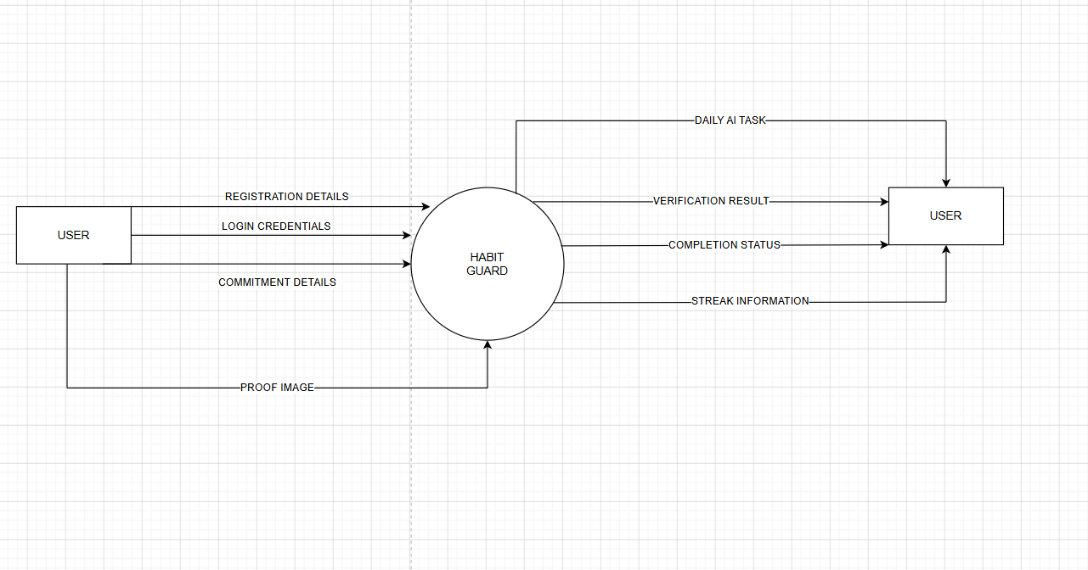
LEVEL – 1
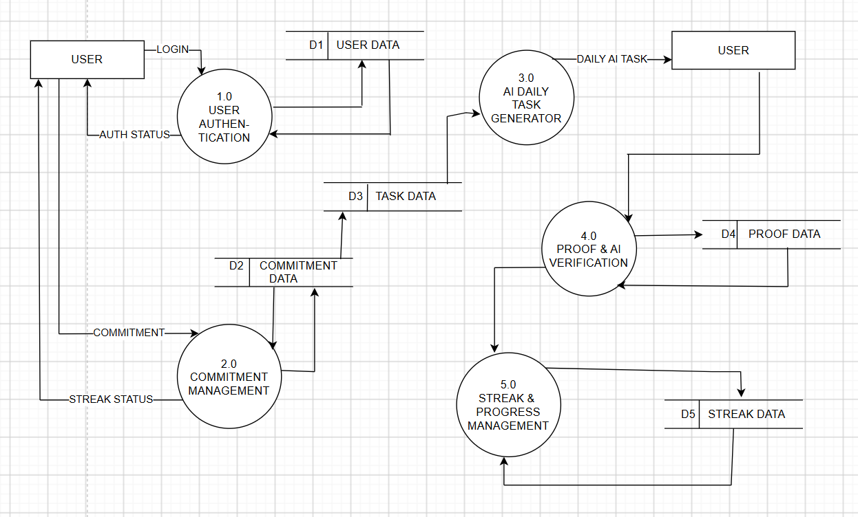
LEVEL—2
- 3.0 AI DAILY TASK GENERATOR
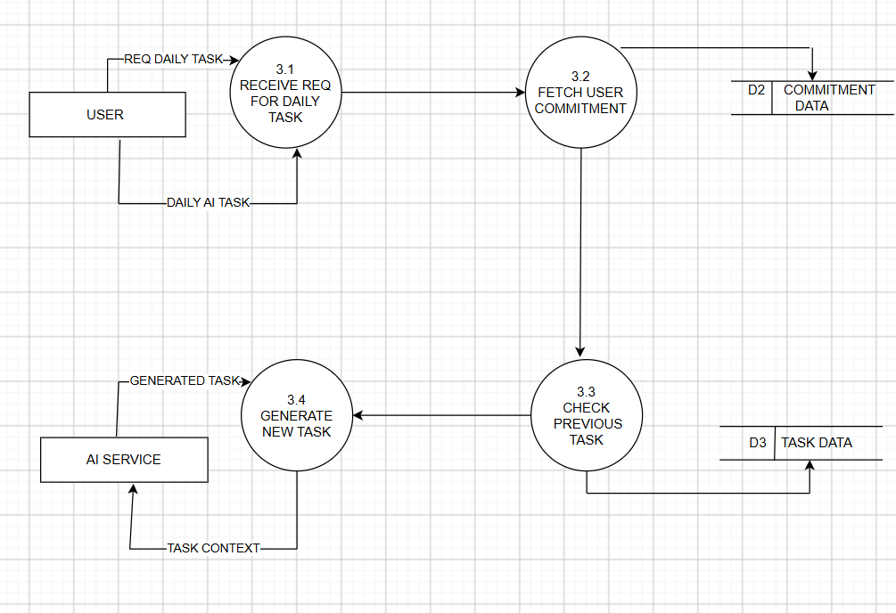

- 4.0 PROOF & AI VERIFICATION
